**Package and Dependencies**

**Ref : https://kubernetes.io/docs/setup/independent/install-kubeadm/**

**Step 1 : Install docker**

# yum install docker -y && systemctl enable docker && systemctl start docker

cat <<EOF > /etc/yum.repos.d/kubernetes.repo

[kubernetes]

name=Kubernetes

baseurl=https://packages.cloud.google.com/yum/repos/kubernetes-el7-x86_64

enabled=1

gpgcheck=1

repo_gpgcheck=1

gpgkey=https://packages.cloud.google.com/yum/doc/yum-key.gpg https://packages.cloud.google.com/yum/doc/rpm-package-key.gpg

EOF

cat /etc/yum.repos.d/kubernetes.repo

setenforce 0

• Disabling SELinux by running setenforce 0 is required to allow containers to access the host filesystem, which is required by pod networks for example. You have to do this until SELinux support is improved in the kubelet.

Kubeadm >>> Kubelet >>>> docker >> > create containers ( api, scheduler,etcd, flannel)

getenforce

yum install -y kubelet kubeadm kubectl

systemctl enable kubelet && systemctl start kubelet

systemctl disable firewalld && systemctl stop firewalld

kubeadm init --pod-network-cidr=192.168.0.0/16

echo $HOME

mkdir -p $HOME/.kube

ls $HOME ls -la

sudo cp -i /etc/kubernetes/admin.conf $HOME/.kube/config

sudo chown $(id -u):$(id -g) $HOME/.kube/config

export KUBECONFIG=$HOME/.kube/config



kubectl version



docker ps

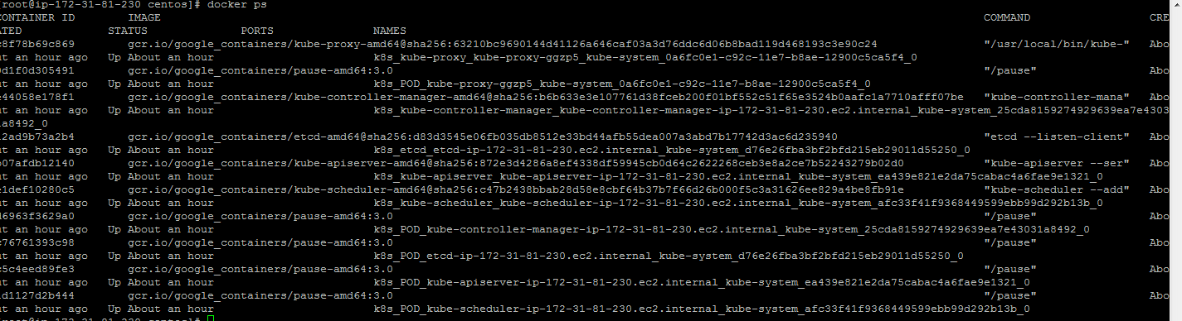

kubectl get nodes

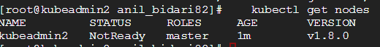

docker ps

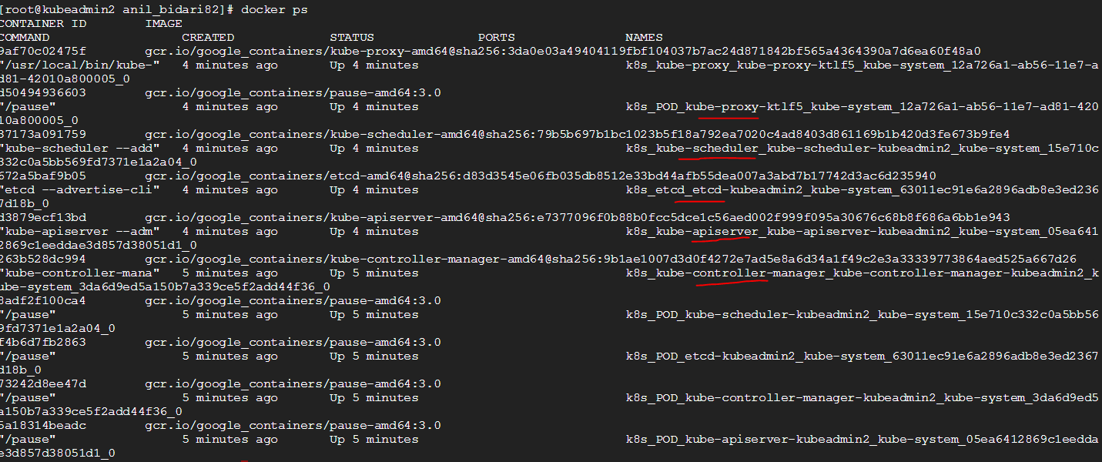

Apply network

sysctl net.bridge.bridge-nf-call-iptables=1

kubectl apply -f https://docs.projectcalico.org/v3.9/manifests/calico.yaml

watch kubectl get pods --all-namespaces



If u want to provioson containers on master

kubectl taint nodes --all node-role.kubernetes.io/master-